Silicone Ring
Silicone rings developed by STUDYLITCS LABS PRIVATE LIMITED play a crucial role in both the automobile and aerospace industries, offering unparalleled sealing performance and reliability. Engineered with advanced silicone materials, these rings provide superior resistance to extreme temperatures, chemicals, and pressure variations, essential for the rigorous environments of both sectors. Their ability to maintain a tight seal over extended periods ensures the integrity of critical components, contributing to enhanced operational efficiency and safety. Whether used in automotive engines or aerospace propulsion systems, these silicone rings exhibit exceptional durability, reducing maintenance frequency and downtime. STUDYLITCS LABS’ commitment to innovation and quality ensures that their silicone rings meet the stringent standards of reliability and performance demanded by modern automotive and aerospace engineering, making them indispensable components in these high-tech industries.

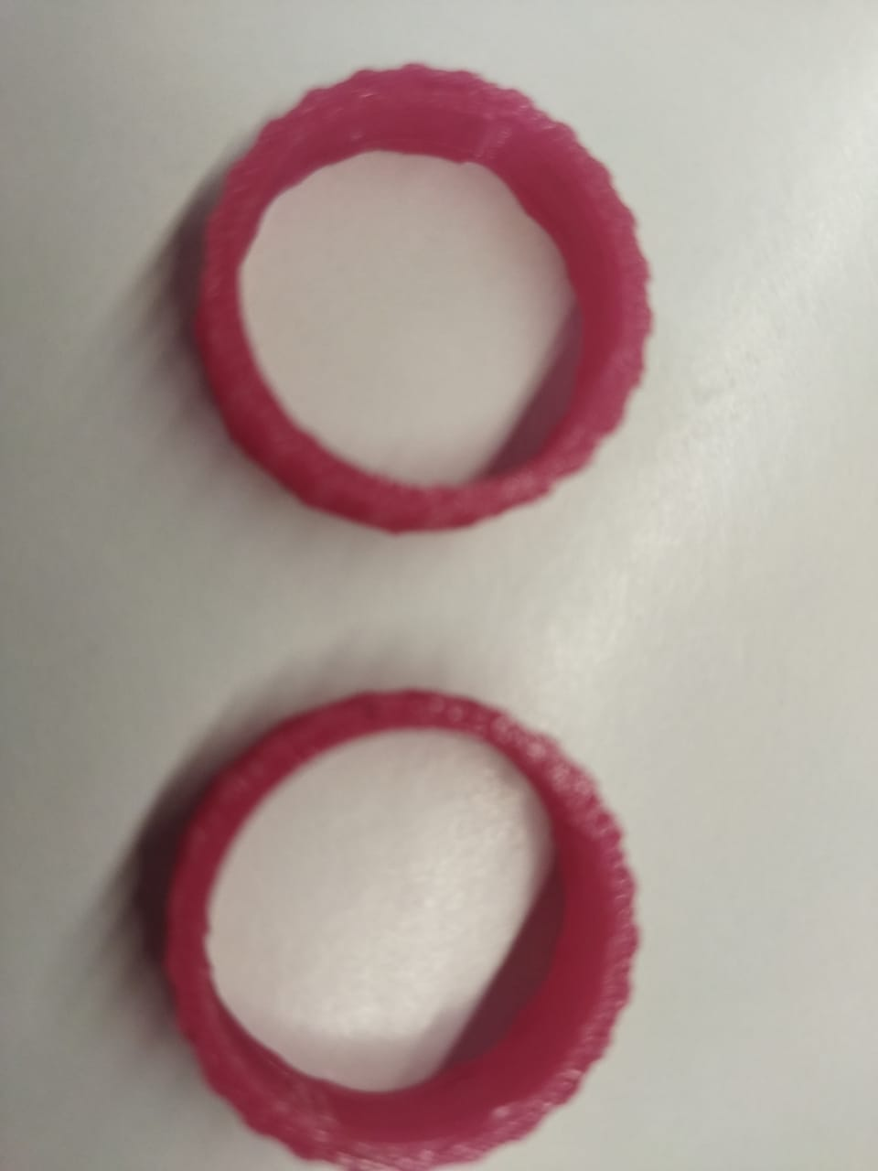

A silicone ring designed as a medical device with silicone rubber represents a crucial innovation in healthcare technology, offering exceptional benefits for patients and medical professionals alike. Made from hypoallergenic silicone, it ensures compatibility with sensitive skin and reduces the risk of allergic reactions, making it suitable for prolonged wear. The ring's flexibility and gentle compression properties provide effective support and comfort in medical applications such as wound care, joint stabilization, or post-operative recovery. Its durable yet lightweight construction allows for continuous use without compromising mobility or comfort, promoting patient compliance and faster rehabilitation. Additionally, silicone's non-slip texture and water-resistant properties enhance safety and reliability in various medical environments. Whether used for orthopedic support, rehabilitation, or therapeutic compression, a silicone ring for medical devices exemplifies advanced technology meeting the rigorous demands of modern healthcare, prioritizing patient comfort, and recovery outcomes.

